***Human Biology ATAR – Task 2:* End of term test**

***Content covered weeks 1-8 (5%)***

|  |  |  |  |
| --- | --- | --- | --- |
| Name: | | | |
| Time allowed: 55 Minutes + 5 minutes reading time | | | |
| **Section** | Your Mark | Marks available | Percentage of Investigation |
| **Multiple Choice (A)** |  | 15 | 25% |
| **Short Answer (B)** |  | 35 | 58% |
| **Extended Response (C)** |  | 10 | 17% |
|  |  | **60** | **100%** |

**Declaration of Authenticity**

I (Student Name) _____________________ declare that this work is my own and I have not plagiarised from any source.

Signature:  
  
Date:

***Section A – Multiple Choice (15 marks)***

*Answer all questions by clearly circling the letter ONLY. Use only a BLUE or BLACK pen. If you make a mistake, place a CROSS through the letter; do not erase or use correction fluid, and circle your new answer. Marks will not be deducted for incorrect answers. No marks will be given if more than one answer is completed for any question*

1. The mitochondria:
   1. give rise to the endoplasmic reticulum
   2. are usually doubled-layered organisms with finger like extensions
   3. are the centre of RNA synthesis
   4. are the centres of cellular respiration
2. Lysosomes are thought to be concerned with:
   1. digestion of cell material
   2. production of energy
   3. passing in of genes
   4. secretion of materials
3. Cell membranes are generally composed of:
   1. A double layer of phospholipids and cholesterol with proteins dispersed throughout the membrane
   2. A double layer of phosphoproteins with glucose dispersed throughout the membrane
   3. A double layer of nucleic acids
   4. A double layer of proteins with phospholipids dispersed throughout the membrane
4. The type of tissue that is responsible for covering the outside of organs such as the kidney and liver, and lining the inside of organs such as the stomach and intestines is the:
5. Connective Tissue
6. Epithelial Tissue
7. Muscular Tissue
8. Nervous Tissue
9. Anabolism can be defined as:
10. reactions in which small molecules are built up to form large molecules and release energy
11. reactions in which small molecules are built up to form large molecules and require energy
12. reactions in which large molecules are broken down to smaller molecules and release energy
13. reactions in which large molecules are broken down to smaller molecules and require energy
14. Looking at the following diagram.

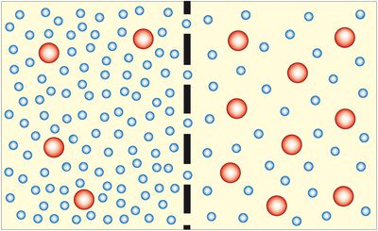

Large solute

 Water molecule

Which of the following situations would occur?

1. Overall the solute would travel through the membrane from right to left
2. Overall the water would travel through the membrane from left to right
3. The water will travel in both directions across the membrane equally
4. Overall the solute will travel through the membrane from right to left and the water from right to left
5. How are ADP and ATP related?
6. they are identical except ADP has more energy
7. ADP has one more phosphate group and less stored energy that ATP
8. they are opposite processes
9. ATP has one more phosphate group and more stored energy than ADP
10. In facilitated diffusion
    1. transport is quicker than normal diffusion
    2. transport is selective
    3. transport of one substance is stopped by another
    4. all of the above
11. A protein is made up of:
    1. simple sugars
    2. fatty acid
    3. glycerol
    4. amino acids
12. Erythrocytes mainly carry:
    1. oxygen
    2. carbon dioxide
    3. oxygen and carbon dioxide
    4. oxygen and nitrogen
13. Referring to the blood vessels in the mammalian body, which statement is always true?
14. arteries carry deoxygenated blood, veins carry oxygenated blood
15. arteries carry oxygenated blood, veins carry deoxygenated blood
16. arteries carry blood towards the heart, veins carry blood away from the heart
17. arteries carry blood away from the heart, veins carry blood towards the heart

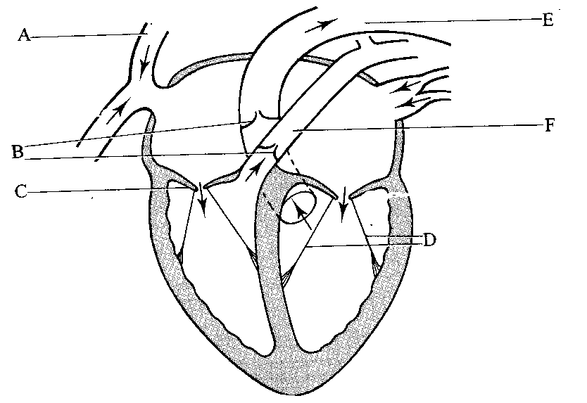

1. The part of the heart labelled A is the
   1. aorta
   2. superior vena cave
   3. semi lunar valve
   4. left atrium
2. What is the function of the structure labelled F?
   1. to carry blood from the body into the right atrium
   2. to carry blood from the right ventricle to the lungs
   3. to carry blood from the lungs to the right ventricle
   4. to carry blood from the body into the left atrium
3. Which of the following is true of gaseous exchange through the wall of the alveoli?
   1. diffusion of carbon dioxide occurs at the same rate in both directions
   2. diffusion of oxygen occurs at the same rate in both directions
   3. diffusion of oxygen is from alveoli to the blood capillaries
   4. diffusion of carbon dioxide is from the alveoli to the blood capillaries
4. The main reason for having millions of alveoli in the lungs is to
   1. fill in an empty space
   2. allow a lot of blood flow to the lungs
   3. increase the surface area of the lungs
   4. allow air to reach the bloodstream

**END OF MULTIPLE CHOICE**

***Section B – Short Answer***

Answer all questions in the spaces provided. Use only BLUE or BLACK pen.

1. The following graph shows the results of an experiment involving the breakdown of starch by an enzyme (4 marks)

**Effect of temperature on breakdown of starch by an enzyme**

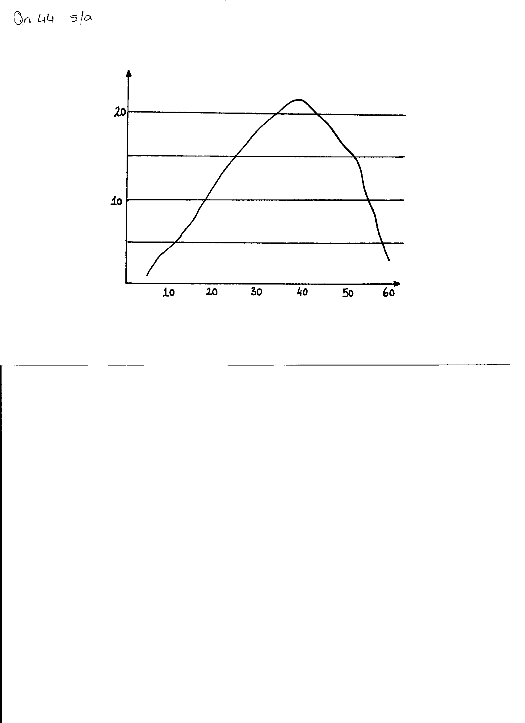

**Enzyme activity in mg of starch broken**

**Temperature in OC**

1. What is the optimum temperature for the activity of this enzyme? (1 mark)

__________________________________________________________________________________

1. Why does the rate of reaction drop rapidly at body temperatures above 45OC? (1 mark)

____________________________________________________________________________________________________________________________________________________________________

1. What is the end product from the digestion of starch? (1 mark)

______________________________________________________________________­­­­____________

1. State **ONE** factor, other than temperature, which affects the activity of an enzyme (1 mark)

__________________________________________________________________________________

1. Use this diagram of the heart to answer the following questions (13 marks)

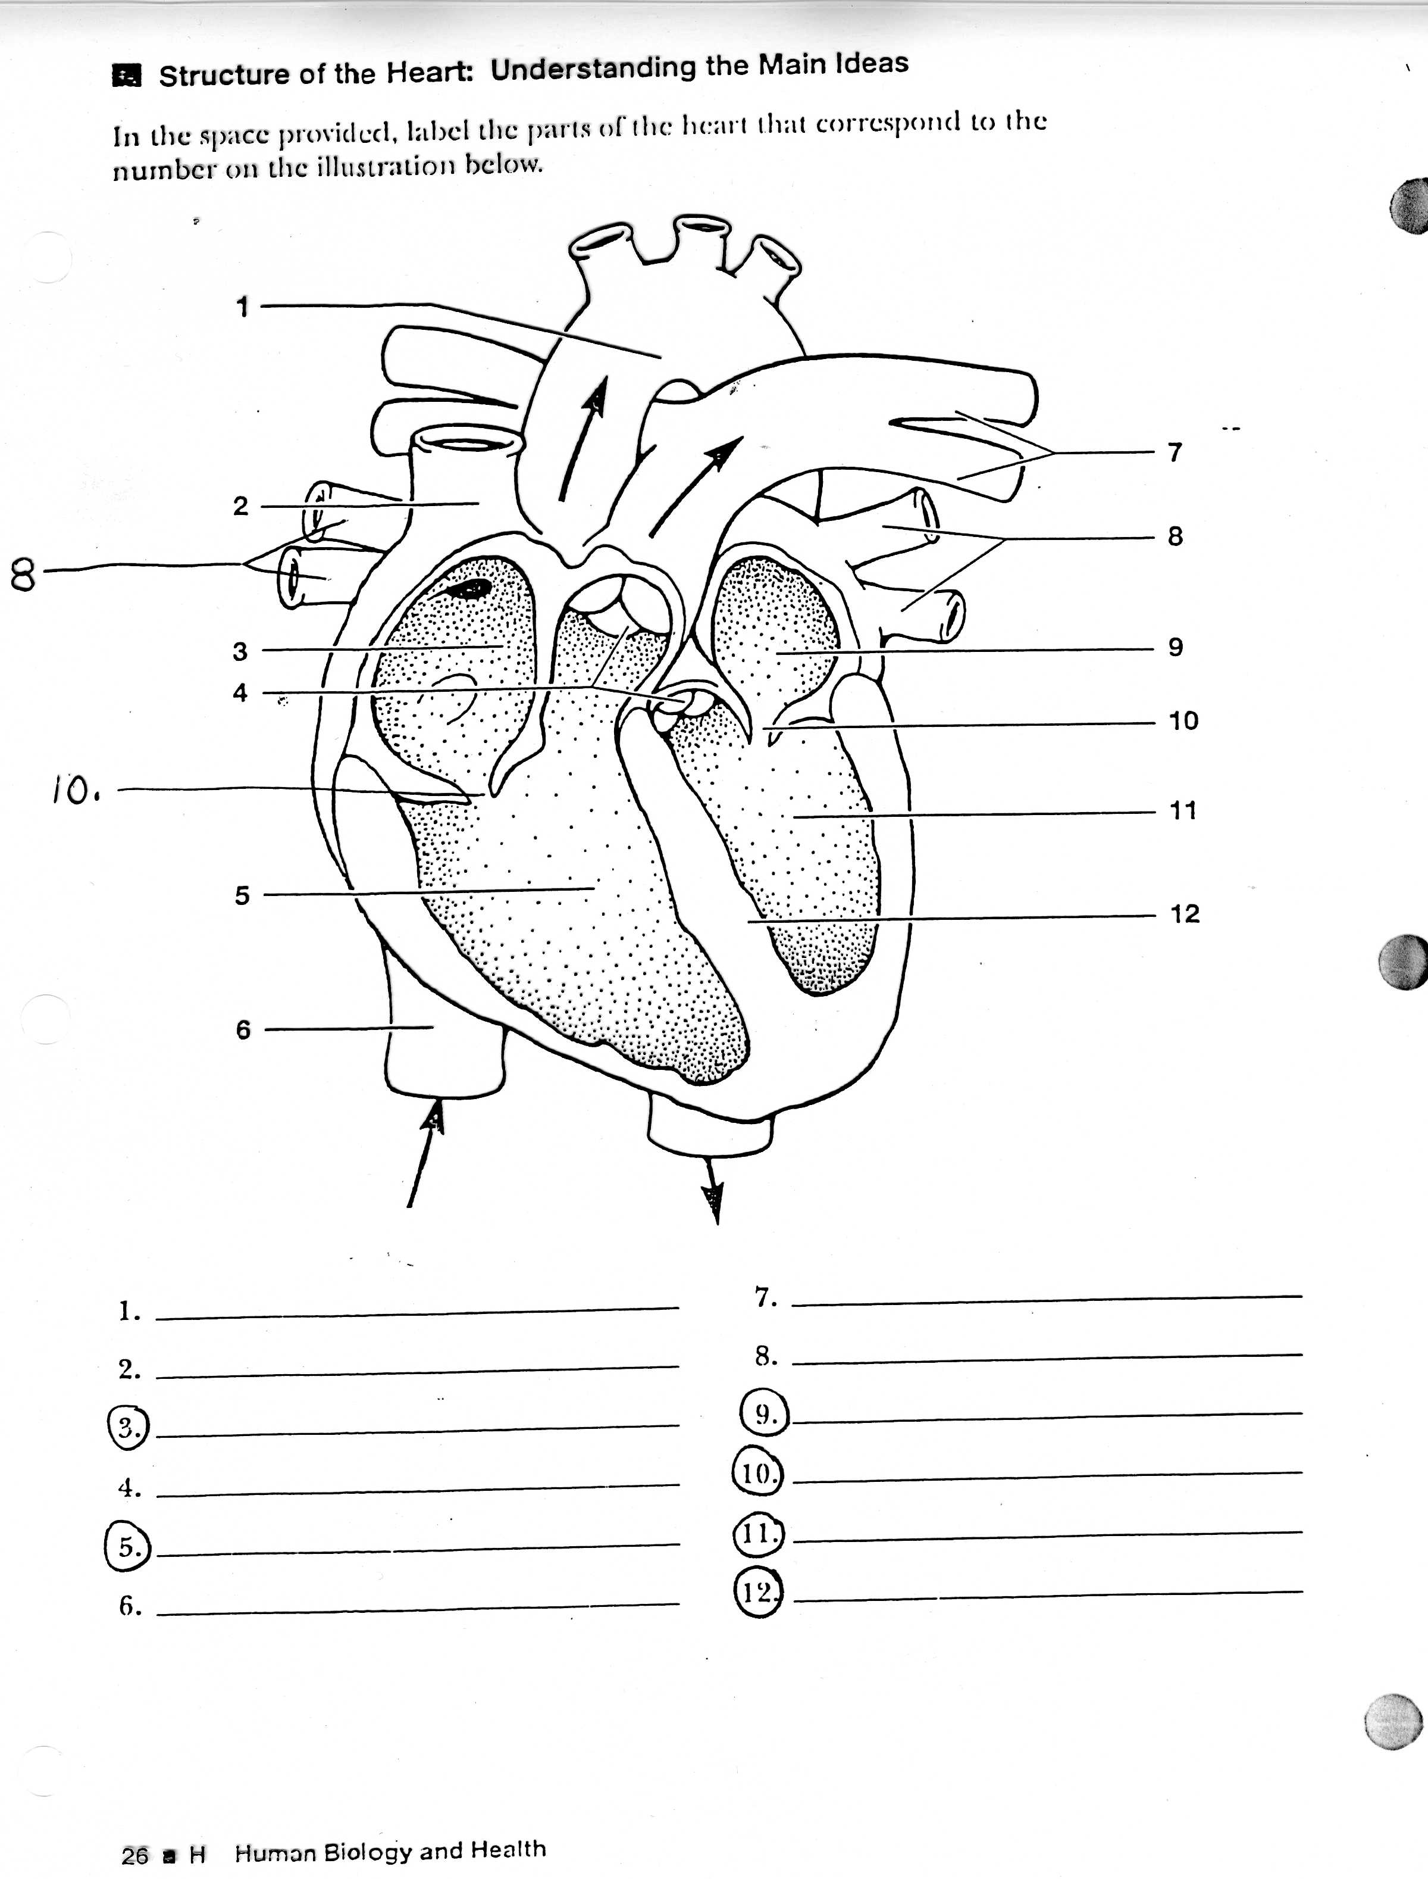EDIT

1. Name the following (2 marks)

structure 10 ____________________________________________________

structure 4__________________________________________________________

1. Explain the function they have in common (3 marks)

___________________________________________________________________________

___________________________________________________________________________

___________________________________________________________________________

___________________________________________________________________________

___________________________________________________________________________

___________________________________________________________________________

1. Which chamber of the heart does the greatest work? Give evidence to support (3 marks)

_______________________________________________________________________________

_______________________________________________________________________________

_______________________________________________________________________________

1. Define Cardiac output and include the formula to solve for C.O (2 marks)

­_______________________________________________________________________________

_______________________________________________________________________________

_______________________________________________________________________________

1. Label the following structures (3 marks)
2. 7 __________________________
3. 12 __________________________
4. 6 __________________________
5. Explain the following processes, where they occur in the cell and the amount of energy each process yields (6 marks)
6. Aerobic respiration (3 marks)

________________________________________________________________________

________________________________________________________________________

________________________________________________________________________

___________________________________________________­­­­­­­­­­­­­­­­­­­­­­­_____________________

________________________________________________________________________

b. Anaerobic respiration (3 marks)

________________________________________________________________________

________________________________________________________________________

________________________________________________________________________

___________________________________________________­­­­­­­­­­­­­­­­­­­­­­­_____________________

________________________________________________________________________

1. Blood is made up of plasma and formed elements. List the three types of formed elements in the table below, and give ONE function of each. (6 marks)

|  |  |
| --- | --- |
| **COMPONENT OF THE BLOOD** | **FUNCTION** |
|  |  |
|  |  |
|  |  |

1. Label the structures in the diagram below, by writing the name next to the matching letter in the table (6 marks)

|  |  |
| --- | --- |
| **STRUCTURE** | **NAME** |
| A1 |  |
| A2 |  |
| C |  |
| E |  |
| G |  |
| H-I |  |

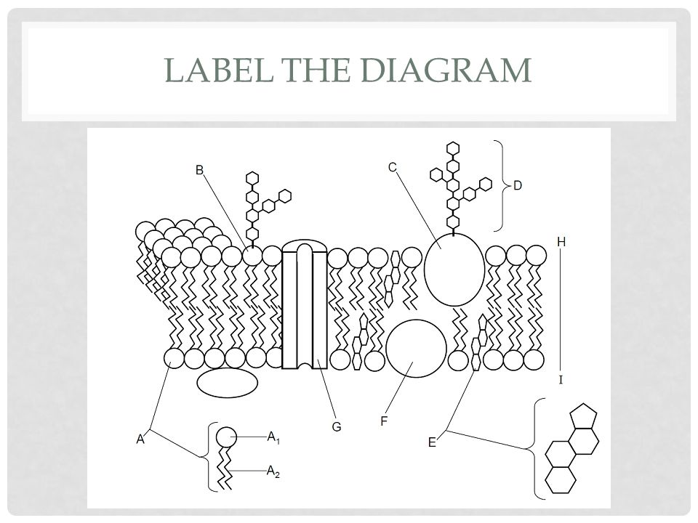

***Section C – Extended Response***

*Write your answer on the lined pages provided. Answers should be in BLUE or BLACK pen*

1. Explain how oxygen and carbon dioxide are transported in the blood. Your answer should explain the different ways they are transported (include comparative amounts and percentages) (10 marks)

*_________________________________________________________________________________________________________________________________________________________________________________________________________________________________________________________________________________________________________________________________________________________________________________________________________________________________________________________________________________________________________________________________________________________________________________________________________________________________________________________________________________________________________________________________________________________________________________________________________________________________________________________________________________________________________________________________________________________________________________________________________________________________________________________________________________________________________________________________________________________________________________________________________________________________________________________________________________________________________________________________________________________________________________________________________________________________________________________________________________________________________________________________________________________________________________________________________________________________________________________________________________________________________________________________________________________________________________________________________________________________________________________________________________________________________________________________________________________________________________________________________________________________________________________________________________________________________________________________________________________________________________________________________________________________________________________________________________________________________________________________________________________________________________________________________________________________________________________________________________________________________________________________________________________________________________________________________________________________________________________________________________________________________________________________________________________________________________________________________________________________________________________________________________________________________________________________________________________________________________________________________________________________________________________________________________________________________________________________________________________________________________________________________________________­­­­­­­­­­­­­­­­­­­­­­­­___________________*

*__________________________________________________________________________________________________________________________________________________________________________________________________________________________________________________________________________________________________________________________________________________________________________________________________________________________________________________________________________________________________________________________________________________________________________________________________________________________________________________________________________________________________________________________________________________________________________________________________________________________________________________________________________________________________________________________________________________________________________________________________________________________________________________________________________________________________________*

*____________________________________________________________________________________________________________________________________________________________________________________________________________________________________________________________________________________________________________________________________________________________________________________________________________________________________________________________________________________________________________________________________________________________________________________________________________________________________________________________________________________________________________________________________________________________________________________________________________________________________________________________________________________________________________________________________*